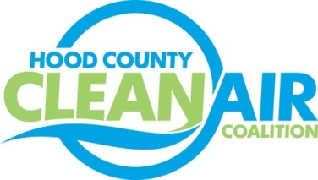
Meeting: Wednesday, December 5, 2018
Neely House
304 East Rucker Street, Granbury, Texas 76048
8:30-10:00 a.m.

Agenda

- Call Meeting to Order
- EPA Updates – Randy Pitre, EPA
- Local Updates – Michelle McKenzie
  - Review of November Meeting Summary
  - Review of Projects
    - Monthly Budget Review for October
    - Status of Projects
  - Reports
    - November Ozone Update
    - Smart Growth Webinar
    - Air North Texas Meeting
- Regional Updates – Michelle McKenzie
  - NCTCOG Analyses of EV Information for Hood County
  - Volkswagen Settlement Beneficiary Mitigation Plan: www.TexasVWFund.org
  - DFW Clean Cities Meeting- January 22, 2018. Register at https://www.dfwcleancities.org/dfw-clean-cities-meetings
  - Funding Opportunities: www.nctcog.org/aqfunding
  - 2015 8-Hour Ozone NAAQS Implementation Final Rule https://www.epa.gov/ground-level-ozone-pollution/implementation-2015-national-ambient-air-quality-standards-naaqs-ozone
  - 2008 8-Hour Ozone NAAQS https://www.govinfo.gov/content/pkg/FR-2018-11-14/pdf/2018-24816.pdf
  - 2018 Transportation Conformity
- Other Discussion
- Adjourn

